3.1 Install and Configure Metric Server

In this demo, we will show you how to install and configure metric server.

The Kubernetes metric server is an aggregator of resource usage data in your cluster, and it is not deployed by default in Amazon EKS cluster. This demo explains how to deploy the Kubernetes metric server on your Amazon EKS cluster. So, let's begin.

* Login to your aws console
* Restart your ec2 instance and your EKS cluster nodes
* Open your terminal and SSH to the ec2 instance

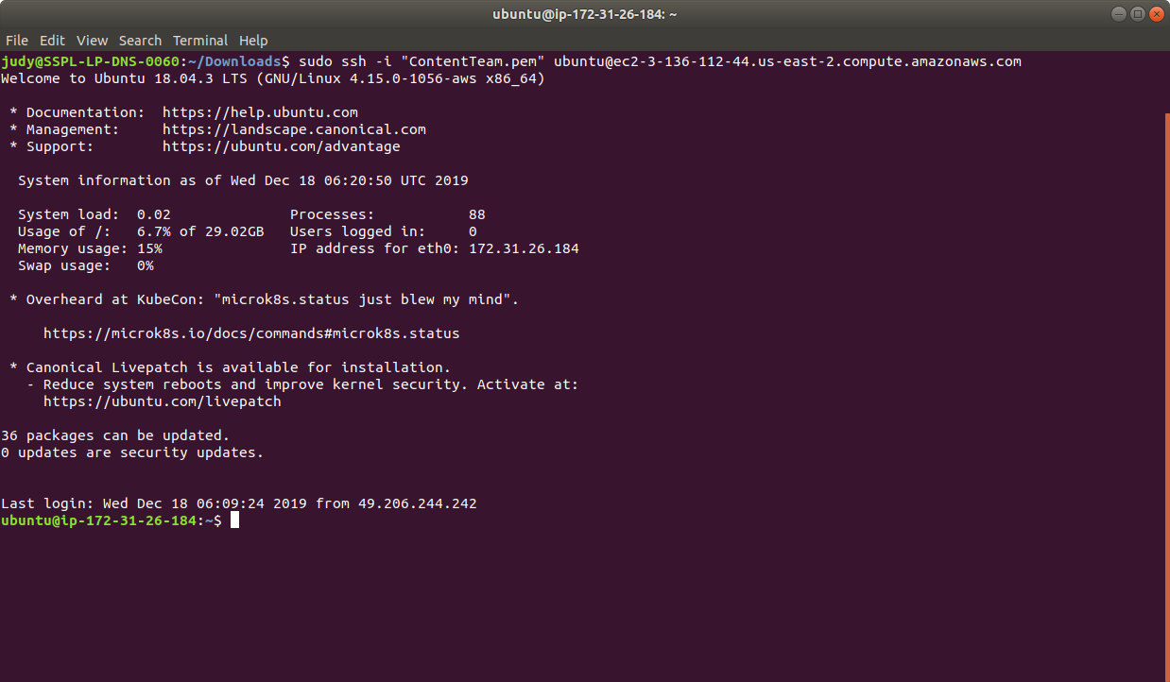

* If you don’t have an existing EKS cluster, create one with the command, **eksctl create cluster --name=myeks-cluster --nodes=2 --region=us-east-2**
* To install metric server from GitHub on an Amazon EKS cluster, use curl and jq. Run **sudo apt install jq** to install jq

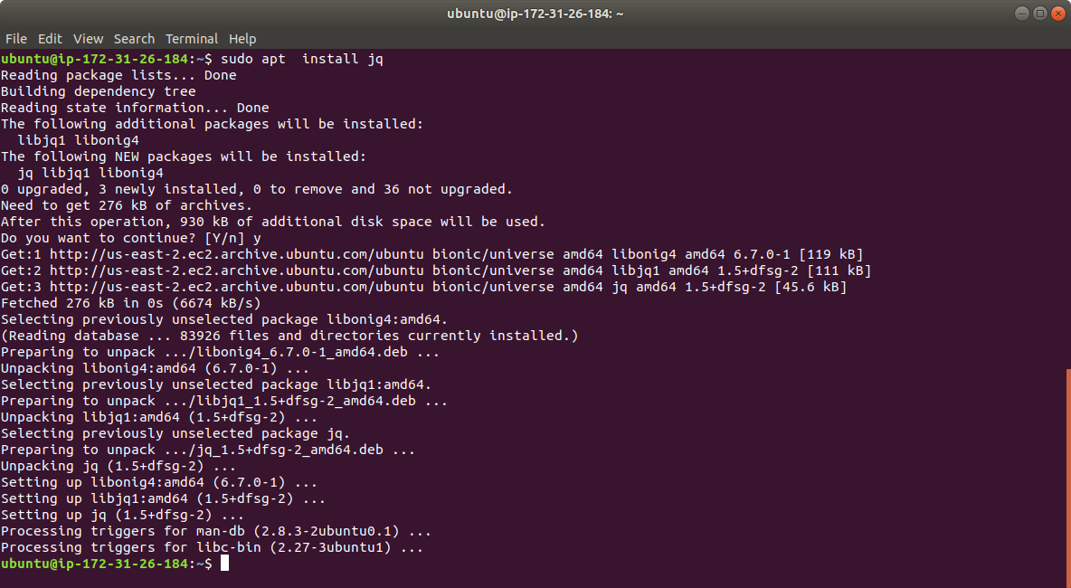

* Copy and paste the commands below and hit **Enter** to execute them.

**DOWNLOAD_URL=$(curl --silent "https://api.github.com/repos/kubernetes-sigs/metrics-server/releases/20705532" | jq -r .tarball_url)**

**DOWNLOAD_VERSION=$(grep -o '[^/v]*$' <<< $DOWNLOAD_URL)**

**curl -Ls $DOWNLOAD_URL -o metrics-server-$DOWNLOAD_VERSION.tar.gz**

**mkdir metrics-server-$DOWNLOAD_VERSION**

**tar -xzf metrics-server-$DOWNLOAD_VERSION.tar.gz --directory metrics-server-$DOWNLOAD_VERSION --strip-components 1**

**kubectl apply -f metrics-server-$DOWNLOAD_VERSION/deploy/1.8+/**

* The above commands download the latest release. Extract it and apply the version 1.8+ manifests to your cluster as shown below:

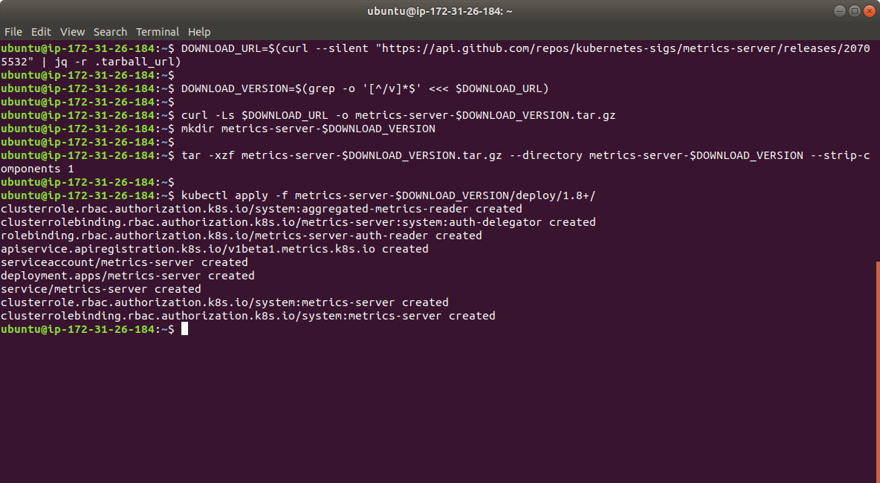

* Verify that the metric server deployment is running the desired number of pods with the following command:

**kubectl get deployment metrics-server -n kube-system**

* The output is as shown below:



This is how we can install and configure metrics server in the Kubernetes Engine.